AI ASSISTED CODING
ASSIGNMENT - 16.3
NAME: P.SAI SHANKAR
HL-NO: 2303A52500 BATCH: 50
Lab 19
Task-1:
-- =========================
-- 1. DROP TABLES (RESET)
-- =========================
DROP TABLE IF EXISTS Appointments;
DROP TABLE IF EXISTS Patients;
DROP TABLE IF EXISTS Doctors;

-- =========================
-- 2. CREATE TABLES
-- =========================
CREATE TABLE Doctors (
doctor_id INTEGER PRIMARY KEY AUTOINCREMENT,
name TEXT,
specialization TEXT
);
-
CREATE TABLE Patients (
patient_id INTEGER PRIMARY KEY AUTOINCREMENT,
name TEXT,
age INTEGER,
gender TEXT
);
CREATE TABLE Appointments (
appointment_id INTEGER PRIMARY KEY AUTOINCREMENT,
doctor_id INTEGER,
patient_id INTEGER,
appointment_date DATE,
FOREIGN KEY (doctor_id) REFERENCES Doctors(doctor_id),
FOREIGN KEY (patient_id) REFERENCES Patients(patient_id)
);
-- =========================
-- 3. ALTER TABLE
-- =========================
ALTER TABLE Patients ADD COLUMN phone TEXT;
-- =========================
-- 4. INSERT DATA
-- =========================
INSERT INTO Doctors (name, specialization) VALUES
('Dr. Ravi', 'Cardiology'),
('Dr. Meena', 'Dermatology');
INSERT INTO Patients (name, age, gender, phone) VALUES
('Arun', 25, 'Male', '9999999999'),
('Priya', 30, 'Female', '8888888888');
INSERT INTO Appointments (doctor_id, patient_id, appointment_date) VALUES
(1,1,'2025-05-01'),
(1,2,'2025-05-02'),
(2,1,'2025-05-03');
-- =========================
-- 5. OUTPUT
-- =========================
SELECT * FROM Doctors;
SELECT * FROM Patients;
SELECT * FROM Appointments;

Output:
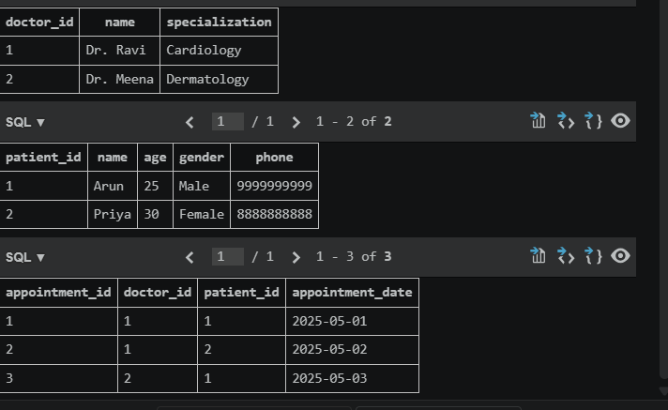
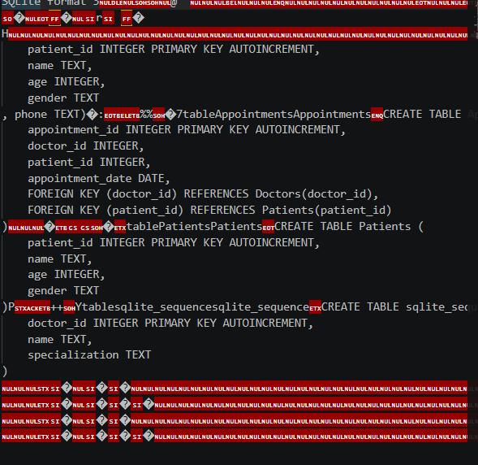

Task-2:
-- =========================
-- 1. DROP TABLES (RESET)
-- =========================
DROP TABLE IF EXISTS OrderDetails;
DROP TABLE IF EXISTS Orders;
DROP TABLE IF EXISTS Products;
DROP TABLE IF EXISTS Users;

-- =========================
-- 2. CREATE TABLES
-- =========================
CREATE TABLE Users (
user_id INTEGER PRIMARY KEY AUTOINCREMENT,
username TEXT,
email TEXT
);
CREATE TABLE Products (
product_id INTEGER PRIMARY KEY AUTOINCREMENT,
name TEXT,
price REAL
);
CREATE TABLE Orders (
order_id INTEGER PRIMARY KEY AUTOINCREMENT,
user_id INTEGER,
order_date DATE,
FOREIGN KEY (user_id) REFERENCES Users(user_id)
);
CREATE TABLE OrderDetails (
order_id INTEGER,
product_id INTEGER,
quantity INTEGER,
PRIMARY KEY (order_id, product_id),
FOREIGN KEY (order_id) REFERENCES Orders(order_id),
FOREIGN KEY (product_id) REFERENCES Products(product_id)
);
-- =========================
-- 3. ALTER TABLE
-- =========================
ALTER TABLE Products ADD COLUMN stock INTEGER;
-- =========================
-- 4. INSERT DATA
-- =========================
INSERT INTO Users (username, email) VALUES
('Sai', 'sai@email.com'),
('Ravi', 'ravi@email.com');
INSERT INTO Products (name, price, stock) VALUES
('Laptop', 50000, 10),
('Phone', 20000, 20);
INSERT INTO Orders (user_id, order_date) VALUES
(1,'2025-05-01'),
(2,'2025-05-02');
INSERT INTO OrderDetails VALUES
(1,1,1),
(1,2,2),
(2,2,1);
-- =========================
-- 5. OUTPUT
-- =========================
SELECT * FROM Users;
SELECT * FROM Products;
SELECT * FROM Orders;
SELECT * FROM OrderDetails;

Output:
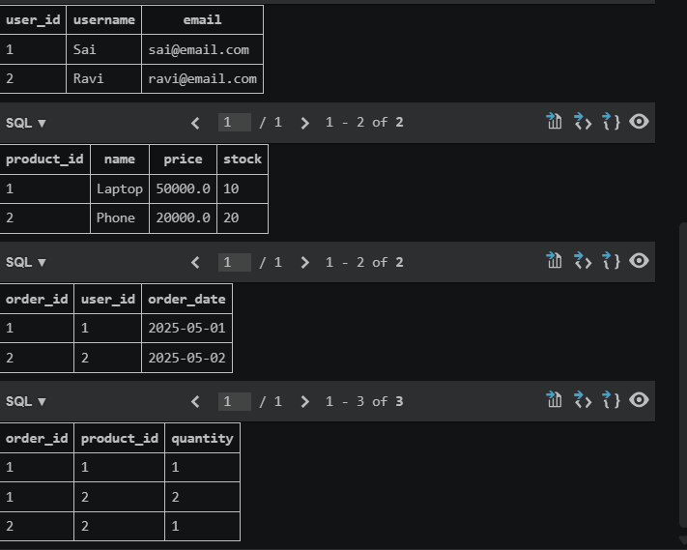
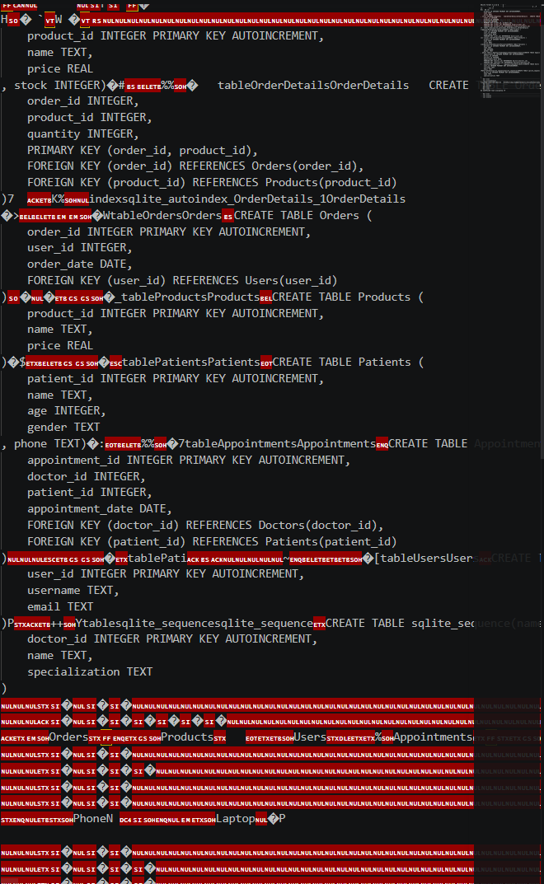

Task-3:
-- =========================
-- 1. DROP TABLES (RESET)
-- =========================
DROP TABLE IF EXISTS Loans;
DROP TABLE IF EXISTS Members;
DROP TABLE IF EXISTS Books;

-- =========================
-- 2. CREATE TABLES
-- =========================
CREATE TABLE Books (
book_id INTEGER PRIMARY KEY AUTOINCREMENT,
title TEXT,
author TEXT
);
CREATE TABLE Members (
member_id INTEGER PRIMARY KEY AUTOINCREMENT,
name TEXT
);
CREATE TABLE Loans (
loan_id INTEGER PRIMARY KEY AUTOINCREMENT,
book_id INTEGER,
member_id INTEGER,
loan_date DATE,
return_date DATE,
FOREIGN KEY (book_id) REFERENCES Books(book_id),
FOREIGN KEY (member_id) REFERENCES Members(member_id)
);
-- =========================
-- 3. ALTER TABLE
-- =========================
ALTER TABLE Books ADD COLUMN category TEXT;
-- =========================
-- 4. INSERT DATA
-- =========================
INSERT INTO Books (title, author, category) VALUES
('DBMS','Korth','Education'),
('AI Basics','Russell','Technology');
INSERT INTO Members (name) VALUES
('Sai'),
('Anu');
INSERT INTO Loans (book_id, member_id, loan_date, return_date) VALUES
(1,1,'2025-03-01',NULL),
(2,2,'2025-01-01',NULL);
-- =========================
-- 5. OUTPUT
-- =========================
SELECT * FROM Books;
SELECT * FROM Members;
SELECT * FROM Loans;

Output:
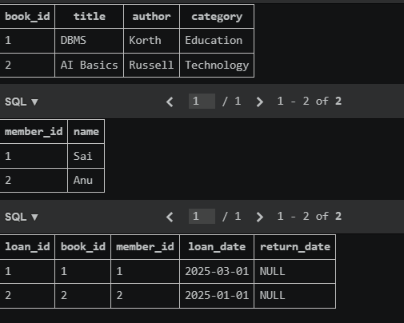
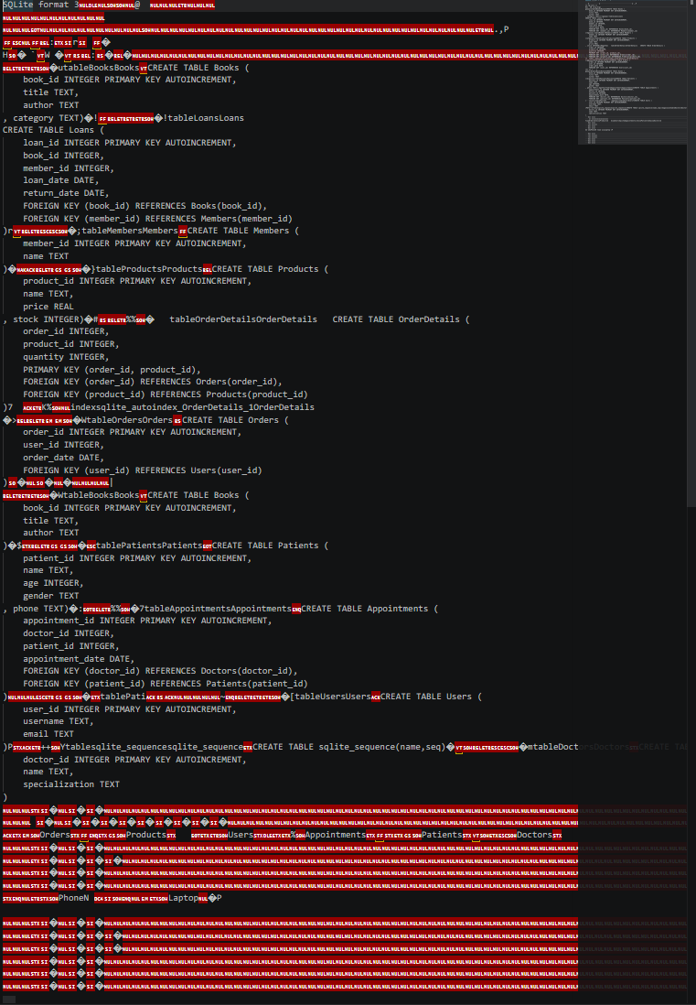

Task-4:
-- =========================
-- 1. DROP TABLES (RESET)
-- =========================
DROP TABLE IF EXISTS Books;
DROP TABLE IF EXISTS Authors;

-- =========================
-- 2. CREATE TABLES
-- =========================
CREATE TABLE Authors (
author_id INTEGER PRIMARY KEY,
name TEXT,
country TEXT
);
CREATE TABLE Books (
book_id INTEGER PRIMARY KEY,
title TEXT,
author_id INTEGER,
FOREIGN KEY (author_id) REFERENCES Authors(author_id)
);
-- =========================
-- 3. INSERT DATA
-- =========================
INSERT INTO Authors VALUES
(1,'John','UK'),
(2,'Ram','India');
INSERT INTO Books VALUES
(1,'Book A',1),
(2,'Book B',2);
-- =========================
-- 4. OUTPUT (QUERY TEST)
-- =========================
-- ORIGINAL
SELECT * FROM Books
WHERE author_id IN (
SELECT author_id FROM Authors WHERE country='UK'
);
-- OPTIMIZED
SELECT b.*
FROM Books b
JOIN Authors a ON b.author_id = a.author_id
WHERE a.country='UK';

Output:
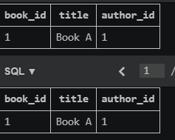
SQLite format 3

_x0007__x0016__x000F_r_x000F_ �
H_x000E_� `
W �
-�_x0007_� )_x0007__x0016_
book_id INTEGER PRIMARY KEY,
title TEXT,
author_id INTEGER,
FOREIGN KEY (author_id) REFERENCES Authors(author_id)
)�! _x0007_�!tableLoansLoans
CREATE TABLE Loans (
loan_id INTEGER PRIMARY KEY AUTOINCREMENT,
book_id INTEGER,
member_id INTEGER,
loan_date DATE,
return_date DATE,
FOREIGN KEY (book_id) REFERENCES Books(book_id),
FOREIGN KEY (member_id) REFERENCES Members(member_id)
)r
_x0007_�;tableMembersMembers CREATE TABLE Members (
member_id INTEGER PRIMARY KEY AUTOINCREMENT,
name TEXT
)�_x0007__x001D__x001D_�}tableProductsProducts_x0007_CREATE TABLE Products (
product_id INTEGER PRIMARY KEY AUTOINCREMENT,
name TEXT,
price REAL
, stock INTEGER)�#_x0007_%%� tableOrderDetailsOrderDetails CREATE TABLE OrderDetails (
order_id INTEGER,
product_id INTEGER,
quantity INTEGER,
PRIMARY KEY (order_id, product_id),
FOREIGN KEY (order_id) REFERENCES Orders(order_id),
FOREIGN KEY (product_id) REFERENCES Products(product_id)
)7 K%
�>_x0007__x0007__x0019__x0019_�WtableOrdersOrdersCREATE TABLE Orders (
order_id INTEGER PRIMARY KEY AUTOINCREMENT,
user_id INTEGER,
order_date DATE,
FOREIGN KEY (user_id) REFERENCES Users(user_id)
)_x000E_�
_x0007_�CtableAuthorsAuthors
CREATE TABLE Authors (
author_id INTEGER PRIMARY KEY,
name TEXT,
country TEXT
)�$_x0007__x001D__x001D_�tablePatientsPatientsCREATE TABLE Patients (
patient_id INTEGER PRIMARY KEY AUTOINCREMENT,
name TEXT,
age INTEGER,
gender TEXT
, phone TEXT)�:_x0007_%%�7tableAppointmentsAppointments_x0005_CREATE TABLE Appointments (
appointment_id INTEGER PRIMARY KEY AUTOINCREMENT,
doctor_id INTEGER,
patient_id INTEGER,
appointment_date DATE,
FOREIGN KEY (doctor_id) REFERENCES Doctors(doctor_id),
FOREIGN KEY (patient_id) REFERENCES Patients(patient_id)
)
user_id INTEGER PRIMARY KEY AUTOINCREMENT,
username TEXT,
email TEXT
)P++Ytablesqlite_sequencesqlite_sequenceCREATE TABLE sqlite_sequence(name,seq)�
_x0007_�mtableDoctorsDoctorsCREATE TABLE Doctors (
doctor_id INTEGER PRIMARY KEY AUTOINCREMENT,
name TEXT,
specialization TEXT
)_x000F_�
_x0019_Orders _x0005__x001D_Products Users_x0010_%Appointments _x001D_Patients
Doctors
_x0005_

Task-5:
-- =========================
-- 1. DROP TABLES (RESET)
-- =========================
DROP TABLE IF EXISTS Registrations;
DROP TABLE IF EXISTS Courses;
DROP TABLE IF EXISTS Faculty;
DROP TABLE IF EXISTS Students;

-- =========================
-- 2. CREATE TABLES
-- =========================
CREATE TABLE Students (
student_id INTEGER PRIMARY KEY AUTOINCREMENT,
name TEXT
);
CREATE TABLE Faculty (
faculty_id INTEGER PRIMARY KEY AUTOINCREMENT,
name TEXT
);
CREATE TABLE Courses (
course_id INTEGER PRIMARY KEY AUTOINCREMENT,
course_name TEXT,
faculty_id INTEGER,
FOREIGN KEY (faculty_id) REFERENCES Faculty(faculty_id)
);
CREATE TABLE Registrations (
student_id INTEGER,
course_id INTEGER,
PRIMARY KEY (student_id, course_id),
FOREIGN KEY (student_id) REFERENCES Students(student_id),
FOREIGN KEY (course_id) REFERENCES Courses(course_id)
);
-- =========================
-- 3. ALTER TABLE
-- =========================
ALTER TABLE Students ADD COLUMN email TEXT;
-- =========================
-- 4. INSERT DATA
-- =========================
INSERT INTO Students (name, email) VALUES
('Sai','sai@email.com'),
('Ravi','ravi@email.com'),
('Anu','anu@email.com');
INSERT INTO Faculty (name) VALUES
('Dr. Kumar'),
('Dr. Rao');
INSERT INTO Courses (course_name, faculty_id) VALUES
('DBMS',1),
('AI',1),
('ML',2);
INSERT INTO Registrations VALUES
(1,1),(2,1),(3,1),
(1,2),(2,2),
(3,3);
-- =========================
-- 5. OUTPUT
-- =========================
SELECT * FROM Students;
SELECT * FROM Faculty;
SELECT * FROM Courses;
SELECT * FROM Registrations;

Output:
